Practical Exercise 2: Retail sales

-- 1. SELECT Statement
--Q1. Display all columns for all transactions.
--Expected output: All columns
SELECT* FROM `workspace`.`default`.`retail_sales_dataset` limit 10;

Output Table:

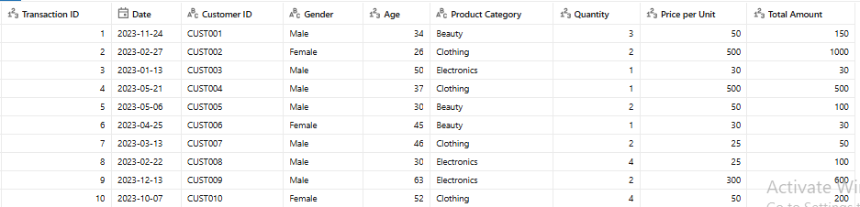

--Q2. Display only the Transaction ID, Date, and Customer ID for all records.
--Expected output: Transaction ID, Date, Customer ID

SELECT `Transaction ID`, Date, `Customer ID`
FROM `workspace`.`default`.`retail_sales_dataset`;
OUTPUT TABLE:
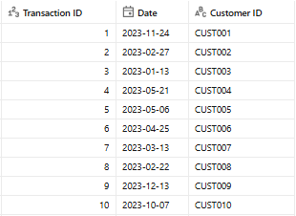

-

-2. SELECT DISTINCT Statement
--Q3. Display all the distinct product categories in the dataset.
--Expected output: Product Category

SELECT DISTINCT `Product Category`
FROM `workspace`.`default`.`retail_sales_dataset`;
OUTPUT TABLE:

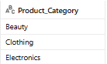

--Q4. Display all the distinct gender values in the dataset.
--Expected output: Gender

SELECT DISTINCT Gender
FROM `workspace`.`default`.`retail_sales_dataset`;

Output table:

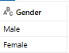

3. WHERE Clause
Q5. Display all transactions where the Age is greater than 40.
Expected output: All columns

SELECT *
FROM `workspace`.`default`.`retail_sales_dataset`
WHERE Age > 40;

OUTPUT TABLE:
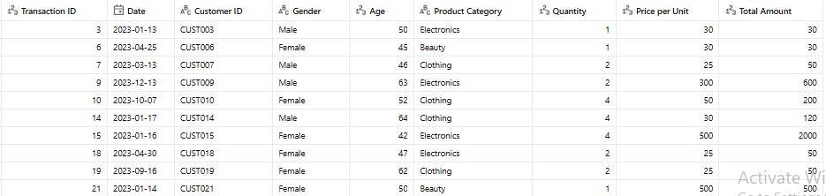

-- Q6. Display all transactions where the Price per Unit is between 100 and 500.
--Expected output: All columns
SELECT *
FROM `workspace`.`default`.`retail_sales_dataset`
WHERE `Price per Unit` BETWEEN 100 AND 500;

OUTPUT TABLE:
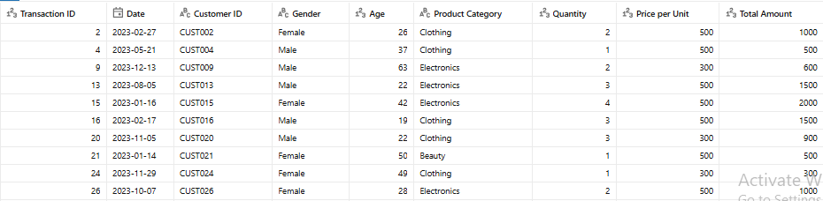

-- Q7. Display all transactions where the Product Category is either 'Beauty' or 'Electronics'.
--Expected output: All columns
SELECT *
FROM `workspace`.`default`.`retail_sales_dataset`
WHERE `Product Category` IN ('Beauty', 'Electronics');

OUTPUT TABLE:
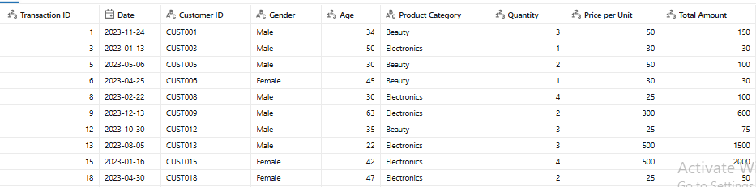

-- Q8. Display all transactions where the Product Category is not 'Clothing'.
--Expected output: All columns
SELECT *
FROM `workspace`.`default`.`retail_sales_dataset`
WHERE `Product Category` <> 'Clothing';

OUTPUT TABLE:
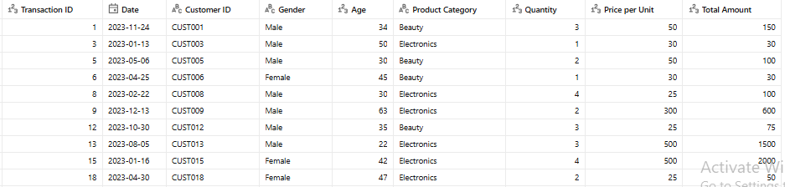

-- Q9. Display all transactions where the Quantity is greater than or equal to 3.
--Expected output: All columns
SELECT *
FROM `workspace`.`default`.`retail_sales_dataset`
WHERE Quantity >= 3;

OUTPUT TABLE:
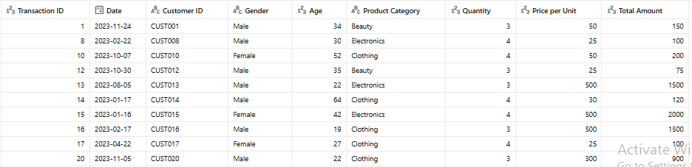

-- 4. Aggregate Functions
--Q10. Count the total number of transactions.
--Expected output: Total_Transactions

SELECT COUNT(*) AS Total_Transactions
FROM `workspace`.`default`.`retail_sales_dataset`;

OUTPUT TABLE:
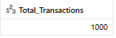

-- Q11. Find the average Age of customers.
--Expected output: Average_Age

SELECT AVG(Age) AS Average_Age
FROM `workspace`.`default`.`retail_sales_dataset`;

OUTPUT TABLE:
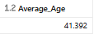

-- Q12. Find the total quantity of products sold.
--Expected output: Total_Quantity

SELECT SUM(Quantity) AS Total_Quantity
FROM `workspace`.`default`.`retail_sales_dataset`;

OUTPUT TABLE:
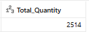

-- Q13. Find the maximum Total Amount spent in a single transaction.
--Expected output: Max_Total_Amount

SELECT MAX(`Total Amount`) AS Max_Total_Amount
FROM `workspace`.`default`.`retail_sales_dataset`;

OUTPUT TABLE:
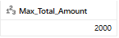

-- Q14. Find the minimum Price per Unit in the dataset.
--Expected output: Min_Price_per_Unit

SELECT MIN(`Price per Unit`) AS Min_Price_per_Unit
FROM `workspace`.`default`.`retail_sales_dataset`;

OUTPUT TABLE:
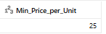

-- 5. GROUP BY Statement
--Q15. Find the number of transactions per Product Category.
--Expected output: Product Category, Transaction_Count

SELECT `Product Category`,
COUNT(*) AS Transaction_Count
FROM `workspace`.`default`.`retail_sales_dataset`
GROUP BY `Product Category`;

OUTPUT TABLE:
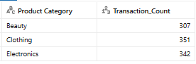

-- Q16. Find the total revenue (Total Amount) per gender.
--Expected output: Gender, Total_Revenue

SELECT Gender,
SUM(`Total Amount`) AS Total_Revenue
FROM `workspace`.`default`.`retail_sales_dataset`
GROUP BY Gender;

OUTPUT TABLE:
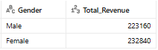

-- Q17. Find the average Price per Unit per product category.
--Expected output: Product Category, Average_Price

SELECT `Product Category`,
AVG(`Price per Unit`) AS Average_Price
FROM `workspace`.`default`.`retail_sales_dataset`
GROUP BY `Product Category`;

OUTPUT TABLE:
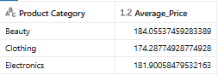
-- 6. HAVING Clause
--Q18. Find the total revenue per product category where total revenue is greater than 10,000.
--Expected output: Product Category, Total_Revenue

SELECT `Product Category`,
SUM(`Total Amount`) AS Total_Revenue
FROM `workspace`.`default`.`retail_sales_dataset`
GROUP BY`Product Category`
HAVING SUM(`Total Amount`) > 10000;

OUTPUT TABLE:


-- Q19. Find the average quantity per product category where the average is more than 2.
-- Expected output: Product Category, Average_Quantity

SELECT `Product Category`,
AVG(Quantity) AS Average_Quantity
FROM `workspace`.`default`.`retail_sales_dataset`
GROUP BY `Product Category`
HAVING AVG(Quantity) > 2;

OUTPUT TABLE:
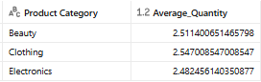

-- 7. CASE Statement
-- Q20. Display a column called Spending_Level that shows 'High' if Total Amount > 1000, otherwise 'Low'.
-- Expected output: Transaction ID, Total Amount, Spending_Level

SELECT `Transaction ID`,
`Total Amount`,
CASE
WHEN `Total Amount` > 1000 THEN 'High'
ELSE 'Low'
END AS Spending_Level
FROM `workspace`.`default`.`retail_sales_dataset`;

OUTPUT TABLE:
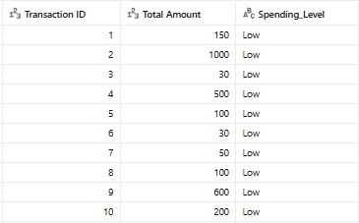

-- Q21. Display a new column called Age_Group that labels customers as:
-- • 'Youth' if Age < 30
-- • 'Adult' if Age is between 30 and 59
-- • 'Senior' if Age >= 60
-- Expected output: Customer ID, Age, Age_Group

SELECT `Customer ID`,
Age,
CASE
WHEN Age < 30 THEN 'Youth'
WHEN Age BETWEEN 30 AND 59 THEN 'Adult'
ELSE 'Senior'
END AS Age_Group
FROM `workspace`.`default`.`retail_sales_dataset`;

OUTPUT TABLE:
